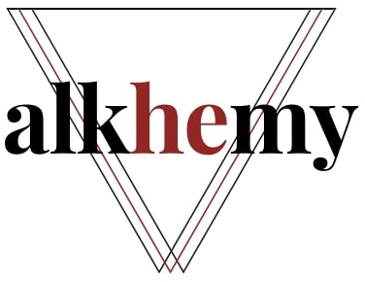
Job Description
Associate Trainer
Job Details
Job Title: Associate Trainer
Location: Remote, with travel across the UK and Ireland for in-person delivery
Pay: £15 – £25 per hour (depending on experience and qualifications, progression is possible)
Contract Type: Freelance | Contract | Flexible
Working Days: Flexible, shaped around your availability and our delivery calendar
About Us
Alkhemy is a family-run organisation that builds affordable, specialist capacity for the people and organisations who support and engage students. We work with students’ unions, higher education providers, and charities, helping the talented, committed people who serve students to do their work well and sustainably, so that students get the quality of experience and support they deserve. We are highly experienced in the higher education and charity sectors, and we want to be respectfully disruptive to current practices.
Job Information
Training is one of the ways we support students’ unions, higher education providers, and charities to build capacity and develop their people. We deliver a broad range of training across the UK and Ireland, including officer training, academic representative training, panel member training, mediation, and bespoke sessions built around a partner’s specific needs.
As demand grows, we are building a pool of associate trainers who can deliver our training with confidence, warmth, and expertise, giving us the capacity to say yes to more partners without compromising on quality.
Our partners look for associates to deliver training in areas such as:
- Officer and student leader development
- Academic representation and student voice
- Campaigning and influencing
- Governance, democracy, and panel member skills
- Wellbeing, boundaries, and working effectively in a students’ union
- Bespoke sessions designed with a partner around their context
Purpose of Role
Alkhemy is searching for experienced trainers and facilitators to add to our pool of associates and help us deliver this training using your facilitation skills, sector knowledge, and experience.
We are looking for people who are experienced at designing and delivering high-quality, participatory training, ideally with a strong understanding of the students’ union, higher education, or charity sectors. We need to know that our partners can trust you to deliver Alkhemy’s training to a high standard, whether online or in person, so proven facilitation experience is key.
You should be comfortable adapting content to the room, reading and responding to a group, and creating a positive, inclusive learning environment. Where you are delivering our existing courses, we will provide the materials and the support you need to deliver them well. Some associates may also have the expertise to help shape and develop new content.
This work is flexible and freelance. We work with associates who have all sorts of different work commitments, so we try to offer work that fits in with your life. In-person delivery involves travel across the UK and Ireland, with reasonable expenses covered.
Interested? To register your interest, email an up-to-date CV, your availability for work, and a brief statement of your relevant skills and training experience to hey@alkhemy.org.uk

